**DAILY ONLINE ACTIVITIES SUMMARY**

|  |  |  |  |  |  |  |  |  |
| --- | --- | --- | --- | --- | --- | --- | --- | --- |
| **Date:** | **07-06-2020** | | | | | **Name:** | **SRILATHA K KAMATH** | |
| **Sem & Sec** | **6 B** | | | | | **USN:** | **4AL17CS099** | |
| **Online Test Summary** | | | | | | | | |
| **Subject** | | **System Software and Compiler Design IA 3** | | | | | | |
| **Max. Marks** | | **30** | | **Score** | | | **24** | |
| **Certification Course Summary** | | | | | | | | |
| **Course** | **Learn Data structures and Algorithms in C++** | | | | | | | |
| **Certificate Provider** | | | **Udemy** | | **Duration** | | | **2.5 hours** |
| **Coding Challenges** | | | | | | | | |
| **Problem Statement:** Python programs to print the first and the last 5 elements of a squared list and to copy the contents of one file to another. | | | | | | | | |
| **Status: COMPLETED** | | | | | | | | |
| **Uploaded the report in Github** | | | | | **YES** | | | |
| **If yes Repository name** | | | | | https://github.com/alvas-education-foundation/Srilatha-K-Kamath-Daily-Report.git | | | |
| **Uploaded the report in slack** | | | | | **YES** | | | |

Online Test Details:

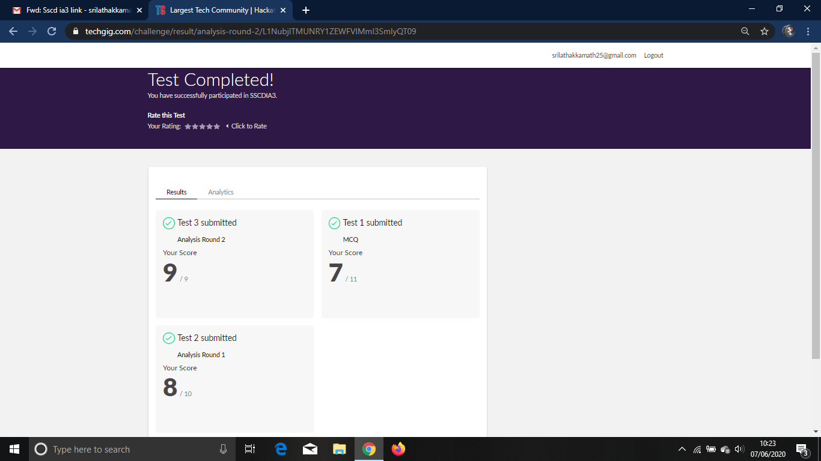

Online Course Details:

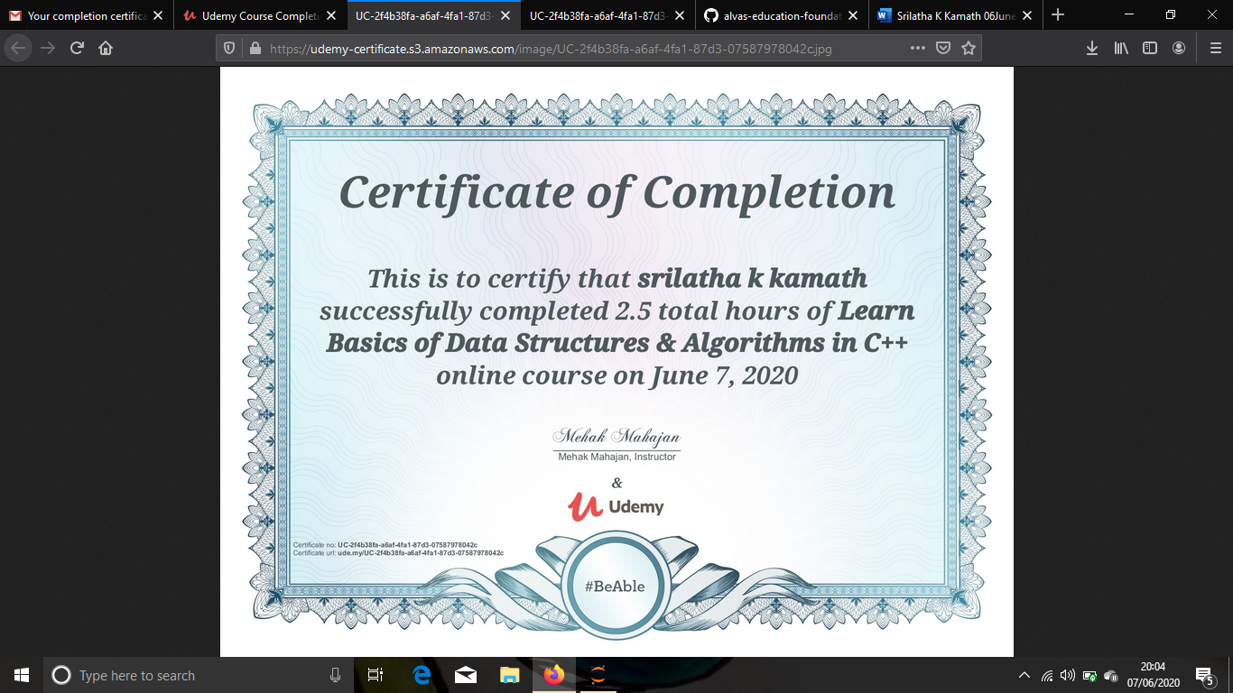

Online Coding Details: 2 Python programs

